**Debugging Angular application in VS Code**

Install following extension in VS Code

1. JavaScript Debugger – (provided - ms-vscode)
2. JavaScript Debugger – (Nightly) ( provided - MicroSoft)

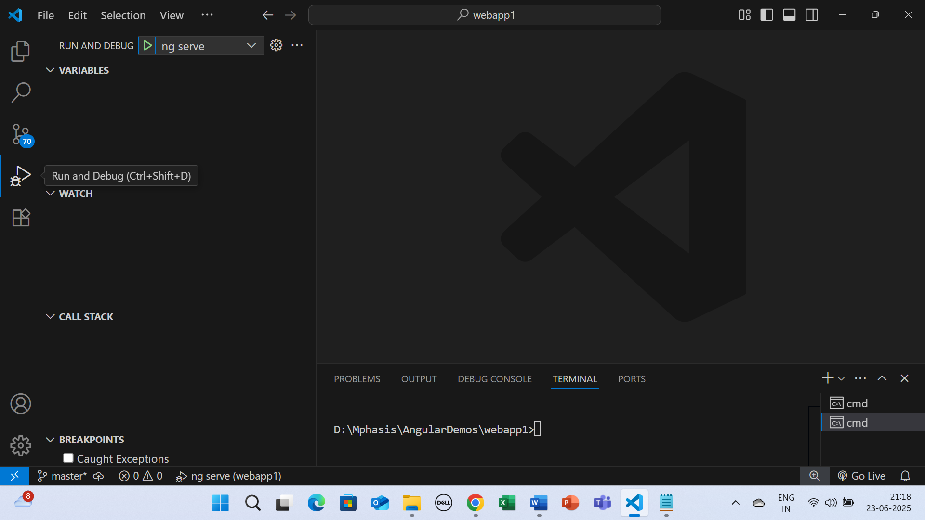

Click on Run and Debug on left side (Ctrl+Shift+D)

Click on setting on top left. You will find launch.json loaded.

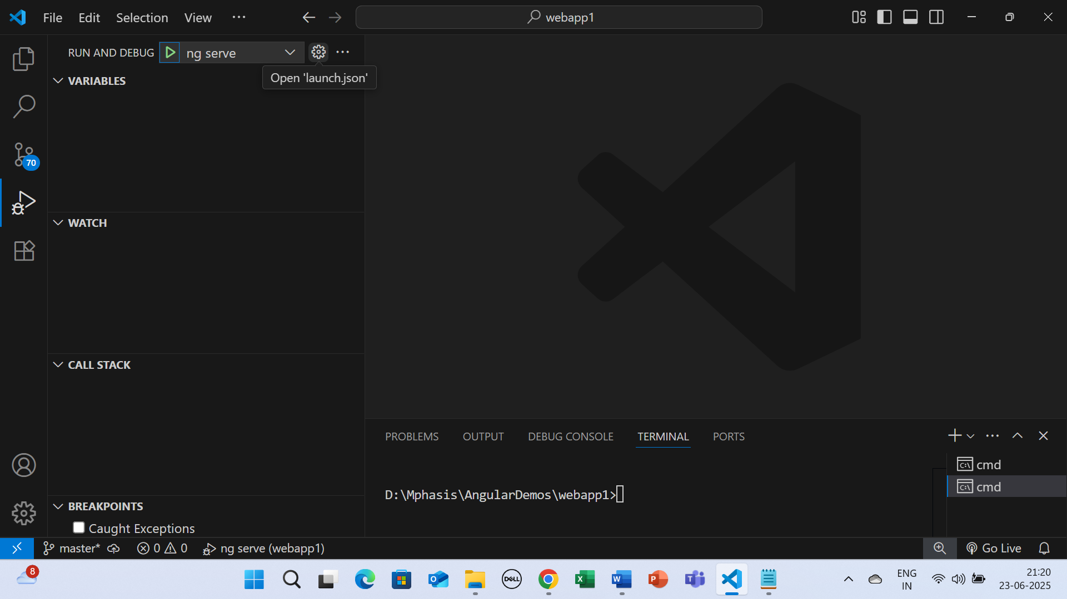

Open launch.json

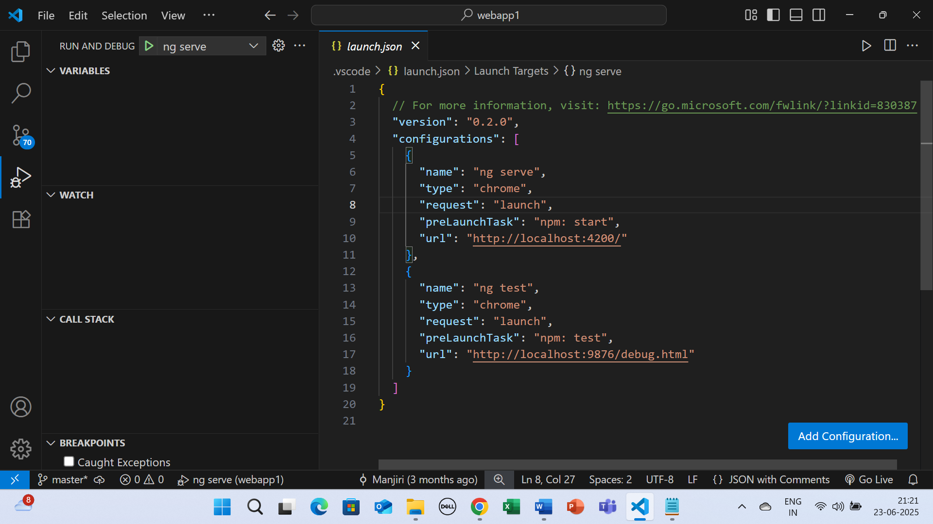

File – launch.json

{

  // For more information, visit: https://go.microsoft.com/fwlink/?linkid=830387

  "version": "0.2.0",

  "configurations": [

    {

      "name": "ng serve",

      "type": "chrome",

      "request": "launch",

      "preLaunchTask": "npm: start",

      "url": "http://localhost:4200/"

    },

    {

      "name": "ng test",

      "type": "chrome",

      "request": "launch",

      "preLaunchTask": "npm: test",

      "url": "http://localhost:9876/debug.html"

    }

  ]

}

This file will be added in .vscode folder of angular application

In .vscode folder you will have task.json file.

File – task.json

{

  "version": "2.0.0",

  "tasks": [

    {

      "label": "ng serve (dev)",

      "type": "shell",

      "command": "ng",

      "args": ["serve", "--configuration", "development"],

      "isBackground": true,

      "problemMatcher": {

        "owner": "typescript",

        "pattern": {

          "regexp": "^(.*):(\\d+):(\\d+) - (error|warning) (TS\\d+): (.*)$",

          "file": 1,

          "line": 2,

          "column": 3,

          "severity": 4,

          "code": 5,

          "message": 6

        },

        "background": {

          "activeOnStart": true,

          "beginsPattern": ".*",

          "endsPattern": "Compiled successfully"

        }

      }

    }

  ]

}

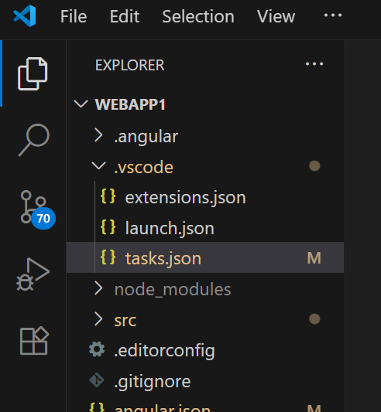

Apply Breakpoint in __.ts file for eg app.component.ts

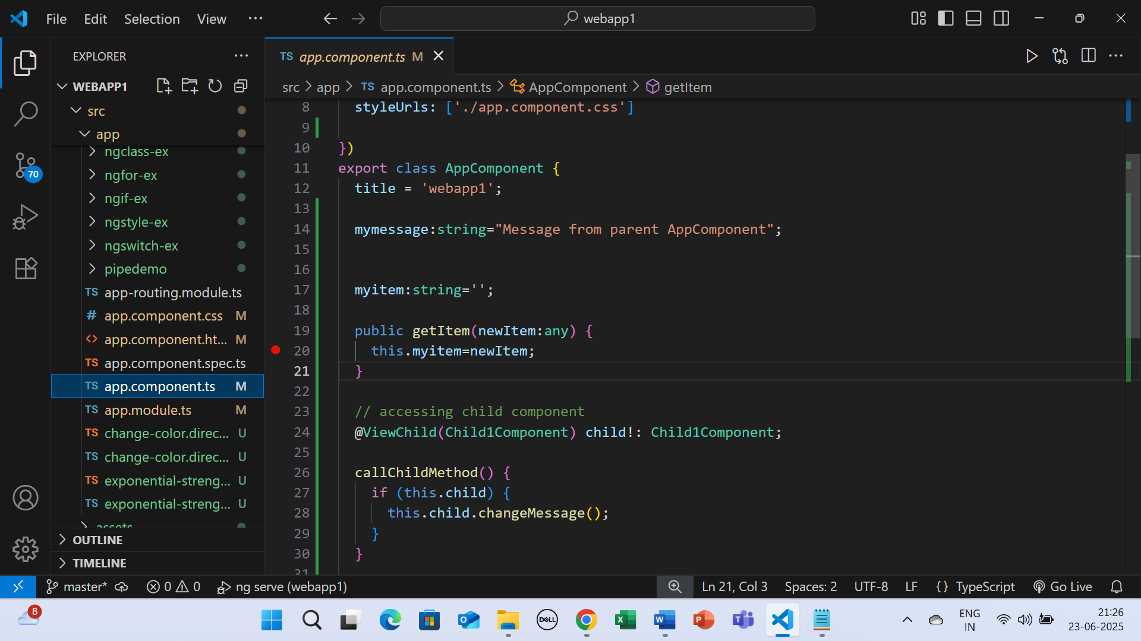

Run Debugger

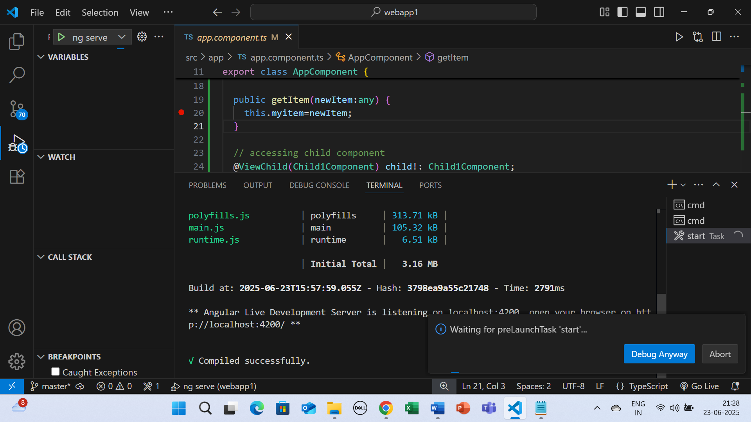

Click on Debug Anyway

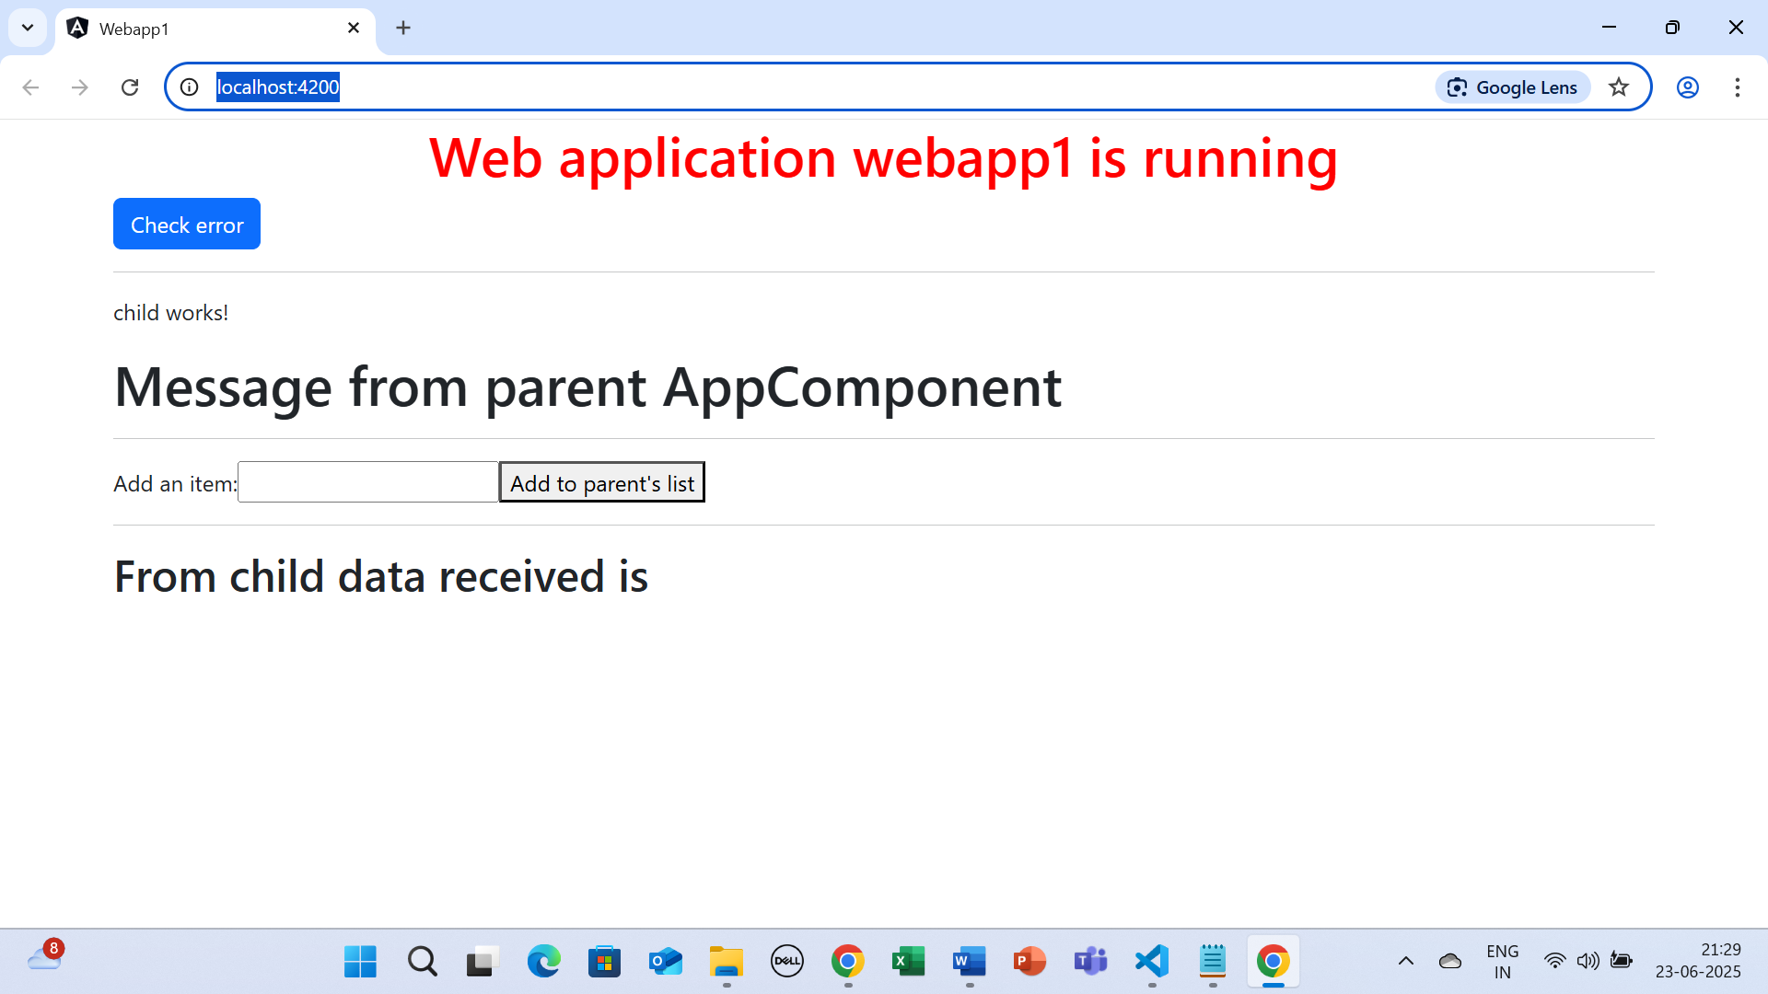

Application will start in debug mode

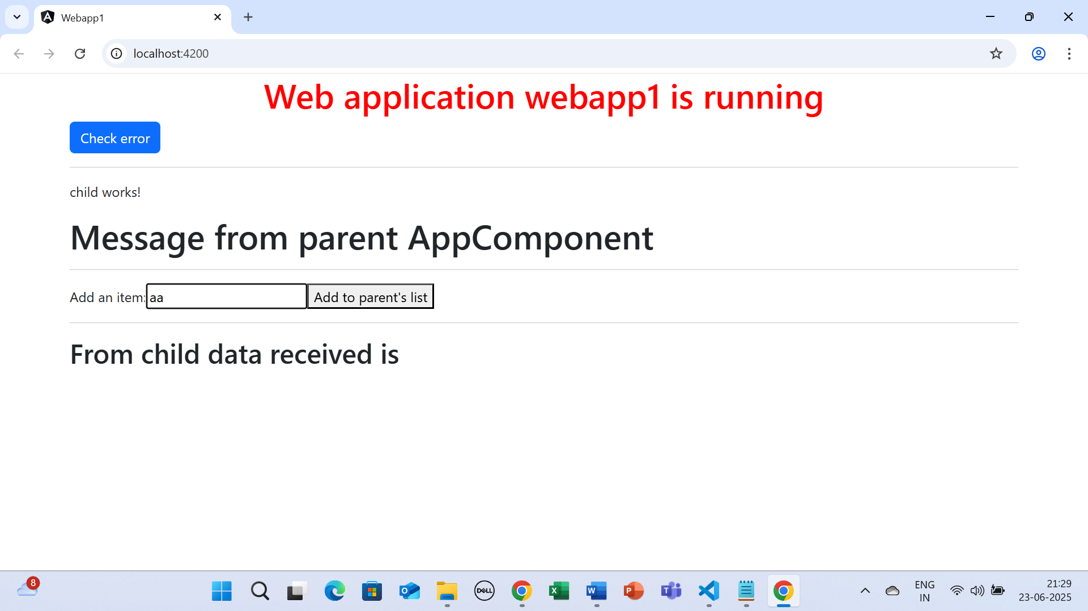

Click on Add to parent’s List

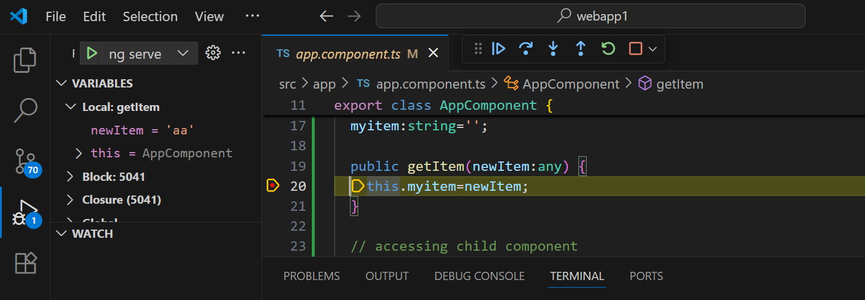

Keep on Pressing F10 or Step Over button to continue.

On left hand side , we can see newItem=’aa’ value